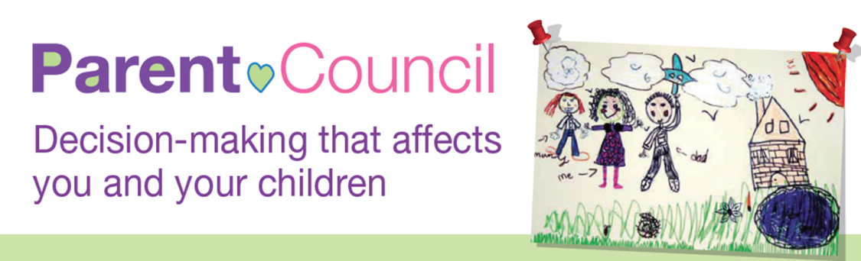

Celebrating Parents and Carers Event

Free family fun day
‘Healthy Lives and Healthy Minds’
Saturday 22nd October 2016, 2pm – 5pm
Haverstock School, 24 Haverstock Hill, NW3 2BQ

Please read the event brief below before filling in the attached form

Event Brief:
Every year we have our Celebrating Parents (in its 11th year) event during Parents week and we invite the Mayor and the Cabinet member for Children Schools and Families. This year’s theme for the event is ‘Healthy Lives and Healthy Minds’.

Our Aims for the Celebrating Parents event are:
- To engage and provide information to parents and carers in the borough about the wide-range of activities in Camden and the local area.
- To promote key messages around promoting health lives and healthy minds.
- To share information and opportunities about the council, local voluntary organisations, community agencies, local activities, further education and local colleges.
- To provide a market place of fun, educational and interactive information advice stalls with fun activities for the whole family.
- To run workshops to explore resident opinion/ undertake consultation.
- To encourage partnerships and collaboration between local organisations.

Target Group:
- Parents, carers and their families living in Camden
- Local statutory, voluntary and community agencies.
- Local health, volunteering, education, leisure, arts and sports providers

This lively and free family event is often well attended, with over 1000 parents, carers and their children coming through the doors last year.

If you would like to contribute to this event in the form of attending and providing an information stall and/or activity please fill in the form below. We would encourage all stalls to have some form of interactive feature, for example, gathering feedback/ engagement from attendees or organising short, accessible activities that children and parents can participate in.

We are seeking additional funding - if you would like to offer a financial contribution to ensure the ongoing sustainability of the event please contact Sarah Moyies on 0207 974 4129.

We look forward to you joining us this year in making this event another huge success!

Event information

Date and Venue:
Saturday 22nd October 2014 from 2pm to 5pm
Haverstock School, 24 Haverstock Hill, NW3 2BQ.

Market Place of Stalls:
All stalls should be activity based and as interactive as possible. We would encourage activities to be based around the ‘health lives and healthy minds’ theme. If you are undertaking a ‘messy’ activity, please ensure you bring floor covers to protect the school floor. This event aims to be a free-to-attend event and stalls should therefore not charge attendees for any activities at the event.

Featured activities on the day:
Additional activities will be provided for attendees (free of charge). These include art activities, shadow puppets, table tennis, interacting with objects, football, bouncy castles, cheer leading, exploring our local environment, climbing wall, under-fives area, face painting, music, smoothie bike, bike corner, plus more!

Setting up for stall holders and entertainers:
Stall holders and entertainers can arrive up to 2 hours (from 12pm) before the event to set up. Stalls will be allocated on a ‘first come first served’ basis.

If you need to drop boxes/equipment off early you can do this between 4pm and 6pm on Friday 21st October. Please do not deliver before 4 PM on Friday. Boxes/equipment must be clearly marked "Celebrating Parents for Nikki Haydon”.

Clearing up for stall holders and entertainers
If you need to leave boxes/equipment over the weekend, it will be possible to collect them on the following Monday. Please indicate if this arrangement is required on your booking form. Pick up time is after 8.30am and no later than 10am on Monday morning, 24th October.

Parking:
Parking is restricted, so please book well in advance if you need a place.

Refreshments for stall holders:
Lunch will not be provided, so do bring a sandwich. There will be water and fruit available free of charge. A small selection of hot food will be provided by the school (with any profit being donated to charity)

Booking confirmation:
We will send you confirmation letters and briefing notes nearer the time.

Celebrating Parents and Carers 2016 event

Booking Form for stall holders and entertainers

Name and Job Title
Name of organisation
Organisation address
Contact telephone number
Contact email address
Title of the stall/activity you are offering
Briefly describe the activity you are offering at this event
Space and Layout - please be as specific as you can be
Resources required – please bring all equipment and materials with you where possible
Number of people you are bringing on the day
Parking space required – (there are a limited number of spaces)

Please RETURN THIS FORM to David Robinson
BY Friday 23rd SEPTEMBER 2016
Via email: david.robinson@camden.gov.uk
You can also contact David on 020 7974 4239 with any queries.

