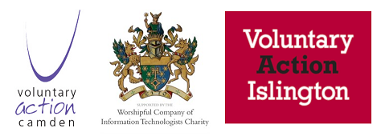

Example Requirements for CRM system

Users (Priority: High, Medium, Low)
Data requirements
- First name
- Surname
- Age or DoB
- Gender
- Ethnicity
- Social media: twitter handle, facebook
- Email, mobile, landline
- Address (verify encachment area)
- Type of user (service user, staff, volunteer, funder, event organizer, 3rd party)
Activities
- Record user details
- Send and receive messages, emails, make phone calls
- Provide advice, online, email, phone
- Respond to queries

Event Management (Priority: High, Medium, Low)
Data requirements
- Event details: venue (virtual or physical), date and time, facilities, budget, expected participants,
- Staff and volunteers
- Communication of event
- Participants booked
- Costs incurred
- Feedback (from users, staff, volunteers, 3rd parties)

Activities
- Plan and Organise event with…
- Organise resources: venue,, volunteers, entertainment, food and drink, zoom setup
- Schedule the event
- Communicate event to users
- Manage bookings, payments
- Run the event
- Obtain feedback from users
- Run a lessons learnt exercise, review feedback and record improvements/changes/follow-on

Fundraising (Priority: High, Medium, Low)
Data requirements
- Funding reqs (budget, timescale)
- List of Funders, status, existing and new
- Funding organization contact details
- Funders requirements (linked document, pdf)
- Use of funds
Activities
- Record funding requirements
- Search and select funders
- Communication with funders
- Record funders requirements
- Provide funders performance feedback on use of funds

Volunteering (Priority: High, Medium, Low)
Data requirements
- Volunteer details (in addition to data collected if already a user)
- Type of volunteering
- Availability
- Start date
- Volunteering performed/ongoing/performance

Activities
- Record Volunteer details
- Allocation of Volunteers
- Review Volunteers performance

