We Make Camden
Creative methods for monitoring, evaluation and learning
2026

Contents
Introduction to this guide 3
Method 1: Voting jars 4
Method 2: Personas 5
Method 3: Using images and emojis 6
Method 4: Snowball feedback 8
Method 5: Visioning and looking to the future 9
Method 6: Photos and storyboards 10
Method 7: Live polls 11

Introduction to this guide
It can feel like surveys and feedback forms are the obvious choice when seeking to hear from residents. This guide sets out a range of other approaches that you may want to consider when engaging participants and residents to learn more about:
- Their views and preferences
- Their feelings and emotions
- The changes that they have experienced due to accessing your organisation’s support or activities
- Their feedback and ideas for ongoing improvement.
This guide is intended for inspiration – it may be that only certain methods are suitable for the people that you work with.
You may choose to adapt methods to make them more applicable or appropriate to your specific context.
Always consider research ethics and safeguarding before using any of these methods (see guidance box below).
Some useful guidance on research ethics, equitable evaluation and safeguarding:
- Social Research Association – Research Ethics Guidance (2021)
- Fulfilling Lives and The National Lottery Community Fund – Trauma-Informed Social Research: A Practical Guide (2021)
- NPC – Equitable Evaluation: An Introduction (2023)
- NSPCC – Research with children: Ethics, safety and promoting inclusion (2023)

Method 1: Voting jars
Voting jars can be used in various ways to gather anonymous feedback in an interactive way. This method involves providing tokens to participants and asking them to drop them in a jar that best matches their emotion or preference.
Some examples include:
- Having a set of jars that represent different feelings (such as joy, excitement, sadness, hope, worry) and providing each member with two tokens – one to place in a jar that best matches their feelings on arrival, and one that matches their feelings at the end of the session. You can make a note of how the number of tokens in each jar has changed from the start to the end of the session.
- To gather ideas and preferences, you can have jars with various options for upcoming sessions and participants can vote on what they would like to see being delivered in the future.
- In a bigger session, where attendees may not be previously known to you, you can use voting jars to collect information about each person e.g. their age, the part of the borough they live in or how they heard about your organisation.

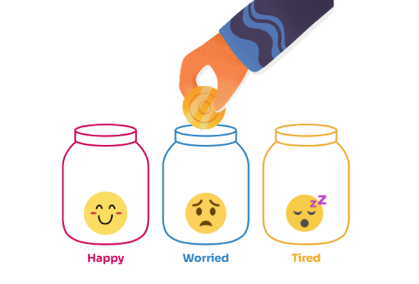

Method 2: Personas
In some circumstances, particularly in group settings, it may not be comfortable or appropriate to ask participants about their personal stories or experiences. If this is the case, you can use fictional personas to encourage discussion.
For example, if your project seeks to support residents to access local meaningful work, you can create a set of three personas that differ and ask the group to share ideas about which types of support could help them on their journey to employment. Individuals can draw on their own experience without needing to share their personal stories.
Employment-related example (to be adapted depending on your project and participants):
 | Persona 1: A 53-year-old woman Nataliya, a Ukrainian refugee with limited English proficiency. She was employed as a dermatologist before coming to the UK but has since been taking irregular shift work in a factory located 45 minutes outside of the borough.
 | Persona 2: A 31-year-old woman Amara, living in King’s Cross who was previously employed as a receptionist in a local school but has not worked for five years as she has been caring full time for her two young children.
 | Persona 3: A 24-year-old man Andres, who has recently completed a college course in Accounting and Bookkeeping. He has submitted multiple applications for entry-level accounting positions in Camden but has so far been unsuccessful.

Method 3: Using images and emojis
The use of images and emojis when engaging with all residents and participants can be helpful in prompting reflection and discussion. Using images can also be particularly supportive when engaging with neurodivergent people and those with varying levels of English proficiency.
Below are a range of approaches that can be used:
- A traffic light - Individuals can use this to reflect on how they are feeling about various aspects of their life or local area e.g. their housing, whether they feel safe, whether they can create social change and whether they have access to local activities.
- A mood ring – Individuals can imagine that they are wearing a mood ring, which colour would the mood ring turn based on how they are feeling?
- An emoji chart – Individuals can identify feelings from emoji visuals and select which best matches how they are feeling.
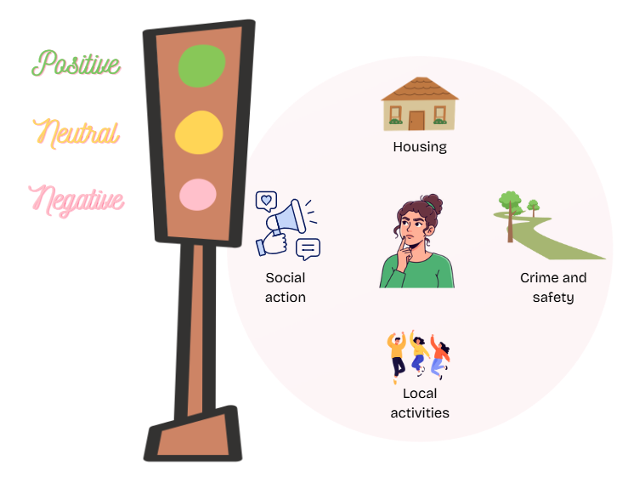

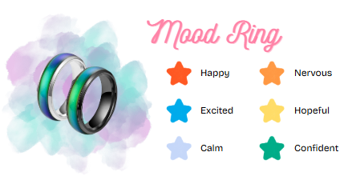

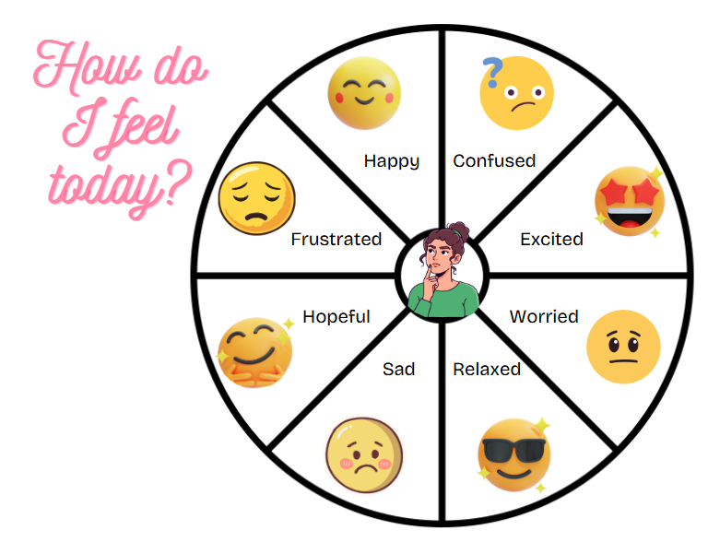

Method 4: Snowball feedback
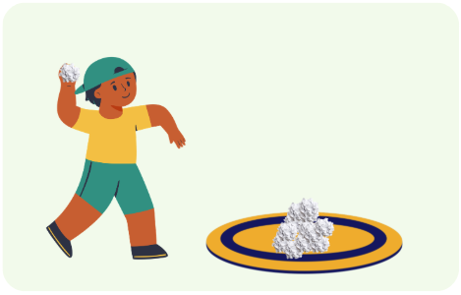
Snowball feedback can be a fun and interactive method for individuals to share their thoughts or feedback in an anonymous way. It can work as a warmup, reflective or planning activity.
A staff member or facilitator can ask group members to each write down e.g.
- Their hopes for how group members will work together (warmup)
- The changes they would like to see due to attending (warmup)
- One thing they liked about the session (reflective)
- One thing they found challenging in the session (reflective)
- How they are feeling after the session (reflective)
- One thing they’d like to see more of in upcoming sessions (looking ahead)
They can then scrunch up their paper into a snowball and throw it into a pile. If appropriate, the facilitator can pick up some of the snowballs at random and share these with the group to invite further discussion.

Method 5: Visioning and looking to the future
If individuals have had an overall positive experience of accessing the activity or service your organisation has provided, it can be challenging for them to identify gaps or suggestions for improvement.
In these cases, it can be helpful to ask people to share ideas on what a future activity or service could look like in an ideal world to ensure that all individuals have a positive experience.
In addition, asking residents to work individually or in groups to imagine that they are one, three or five years from now, can help with goal setting and identifying sought outcomes.
For example, if you are providing cookery classes, you could ask:
- Imagine we are running this course of cookery classes in 2027 to a new group of residents, when should the classes take place to maximise the number of residents that could attend?
- Imagine it is one year from now, which changes would you like to see for yourself and your course mates as a result of attending these cookery classes?



Method 6: Photos and storyboards
Using photos or storyboards can be a creative way to engage with individuals about their story or experience.
For example, you could provide a group with a selection of magazines and ask them to select images or draw pictures that represent aspects of their life, their views or their journey.
If safe and appropriate, you can also ask individuals to capture some images to illustrate their journey over time. This can be an effective alternative to requiring individuals to create a written log or journal.

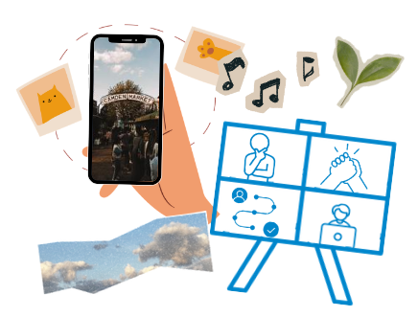

Method 7: Live polls
Platforms such as Mentimeter enable you to gather live feedback including:
- Anonymous open-ended responses (e.g. if you are asking residents to reflect on the things they found enjoyable about the activity)
- Multiple choice answers (e.g. if you are asking residents to what extent they agree with a statement or to vote on a set of options)
- Word cloud suggestions (e.g. if you are asking residents to share a feeling, hope or word association)
Individuals can join and participate live using a numerical or QR code on their phone, tablet or computer. This is useful for gathering instant feedback from a large group e.g. at an event. It can also be useful for gathering anonymous feedback as a way to stimulate discussion in a smaller group setting. Using live polls reduces the need for follow up surveys which may see a lower response rate.



About Rocket Science
Rocket Science is a social purpose business, working towards a future where everyone can live healthy, happy, and fulfilling lives.
Our objectives are to help our clients reimagine systems, maximise investment to have the greatest impact and transform lifetime outcomes using a whole-person and prevention lens. We do this through research, mapping and analysis, evaluation and impact measurement, strategy and service design, participatory and peer research, learning, collaboration, and end to end fund management.

Please contact Rocket Science for more information.
info@rocketsciencelab.co.uk

rocketsciencelab.co.uk
Edinburgh | London | Newcastle
© Rocket Science UK Ltd

